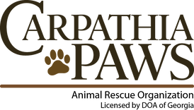
1534 Airport Rd. Hinesville GA 31313
carpathiapaws@gmail.com

Board Members as of December 2020
-Board members are strictly volunteer
President: Meike Kielas (Wilder)
Vice President: Maryann Smith
Secretary: Donnie Smith
Treasurer: Sarah Crawford
General Member: Janet Lyle
General Member: Monica Brown

Staff as of December 2020
Shelter Manager: Mellisa Ballard

Sincerely,

Sarah Crawford
Treasurer

Carpathia Paws, Inc. Tax ID number 94-3465120, phone (931) 542-7024, fax (866) 740-0286

