April 2, 2018

TO WHOM IT MAY CONCERN

Below is the number of animals that were handled by the Liberty County Animal Control during years, 2016, 2016, 2017 and year to date 2018. It also indicated the disposition of those animals as to their status.



If there are any questions concerning this information feel free to contact me.

Sincerely,

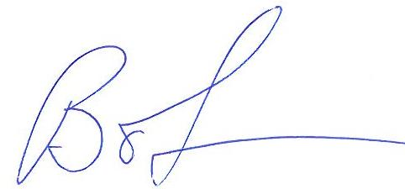

Bob Sprinkel

Assistant County Administrator

Liberty County Georgia